WELCOME TO WOMEN’S MINI WEEK 2024

We are delighted you are attending this year’s event. Have fun!

Introductions and Activity Descriptions

**INTRODUCING**

Hello! I am **Rev. Dr. Kathy Monson Lutes**, mother, grandma, daughter, sister, widow, friend, priest. The work God has called me to is to equip and empower followers of Jesus for the mission of carrying God's healing and reconciliation into the world.

I have recently retired and moved back to my homeland in the Twin Cities of Minnesota. I served at Trinity Episcopal in Janesville before retiring, and before that, St. Andrew’s in Rapid City, South Dakota.

My ministry has been shaped by my passion for faith formation, equipping God’s people to be God’s ministers in the world, and welcoming children as full participants in the body of Christ and trusting them with things and moments of great value during worship.

I came to the Episcopal church about one year after my husband and I were married. We had both been shaped and formed in the church, I was Catholic, my husband Evangelical Free Church. We were looking for an expression of our faith that was a middle way, and we found it at the Episcopal church.

I am excited to be with you all at Women’s Mini Week, and to partner with you in new discoveries on our common journey as we follow Jesus together.

**Nurse** - Conni Brandt has been a registered nurse for 43 years and counting. If you need nursing care during the night, you’ll find her on the porch of Clearwater Lodge.

**ACTIVITY DESCRIPTIONS**

**(See the schedule for when and where)**

**\* Beginning Crochet** - Stephanie Rogers and Janice Wittkopp - Learn the basics of crochet. Hooks and yarn will be provided. * Limited class size, sign up upon arrival at camp.

**Book Discussions**–

Mindy Holt – “These Precious Days,” by Ann Patchett will be discussed.

“Mended in a Broken World” by Brad Bartlett will be discussed with Rev. Kathy

**Book Exchange** - Rita Lynes - Bring a favorite book, wrapped in paper without a label, and we will have a “Blind Date with a Book” book exchange.

**Camp Walk** – On Sunday afternoon, you can take a walk around camp with Barb McFadden. You’ll see units “way back” in the woods, as well as the archery field and far-away meadow – all located within Camp Lakotah’s boundaries. Great for new Mini Week Woman!

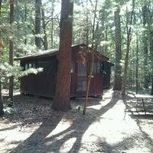

**Campfire, Songs, and S’mores**Join us around the campfire Sunday evening for songs and s’mores. Meet new campers and say hello to old friends.

**Chair Yoga** – Sue Stenz – Come for an all-levels yoga class where beginners are celebrated, and experienced practitioners are encouraged! This class cultivates awareness and deep relaxation through meditation, breath work, and gentle stretches all without the stress of getting up and down off the floor.

**Comfort and Joy** - Conni Brandt - Bring your hair brush and we will take turns brushing each other’s hair and sharing other self-care and joyous ideas.

**Conversation with a Priest** - Rev. Kathy - enjoy one on one time with Rev. Kathy to talk, to learn, to pray. Whatever you need. * Sign up upon registration.

**Devotions (Morning and Evening)** – Rev. Kathy– You may end your day, and begin the next day, with a few brief devotional prayers.

**Fun with Ukuleles** – Dee Kaker– An introduction to the uke for beginners who never held one and a review for others. You’ll discover all the most common chords used and learn a couple of songs. Then there will be wailing and strumming and stomping to the tunes.

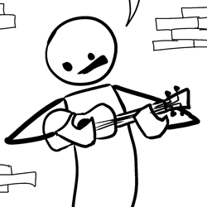

**Group Event Picture** – 11:45 Tuesday before Lunch – Gather at Hollister Lodge’s outdoor chapel for a picture of EVERYBODY. It will be our Facebook cover photo for next year.

**\* Hand Stamped Cards -** Rachel Durtschi - Creating hand stamped cards will be offered Tuesday morning and afternoon. Limited class size, sign up upon arrival at camp.

**Kayaking and Exploring God’s Creation -** Janice Wittkopp - learn to kayak and watch for wildlife on the shores of the lake. Limited attendance available. Kayaks and safety vests provided. Bring your binoculars!

**Walking the Labyrinth** – Stefanie Holt– A labyrinth is used for walking meditation. It is a single winding path from the outer edge in a circuitous way to the center.

**Line Dancing** – Janice Wedde – Everybody is invited to the Friendship Lodge on Monday night to learn fun and easy line dances. Bring your dancing shoes!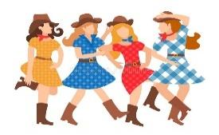

**Massages**– Michelle and Mona are both licensed massage therapists who practice in Wautoma, Oshkosh, and Appleton. They both offer Swedish relaxation massage but will also work on targeted areas. They will adjust pressure to your comfort level and leave you feel relaxed and refreshed. Hot towels and aromatherapy will also be included in your massage. They look forward to meeting everyone and sharing some healing.

**Retro Dance Party** - Tami Carlson - Get your groove on with a fun Retro Dance Party in this Zumba-like class. Super fun!

**Rocking the Prayer Book Rev. Kathy Munson**

Getting to know your Book of Common Prayer (even if you don’t have one)

There are so many times when we don’t have the words to praise God, to ask for forgiveness, to pray for our friends and the whole world. Our Prayer Books are a gift of word, image, love, and compassion. Let’s rock through it and see what’s there! And, especially in this triennial year of General Convention, when what is the Book of Common Prayer is changing, rather than be afraid of change, let’s learn about it and rejoice in this wonderous book.

**Service Project** – This year we will collect bladder protection products for men and women in need. Please drop off the products at camp check in.

**Silent Auction** – All proceeds go to the scholarship fund, so anybody can attend Mini Week, regardless of finances. Bring anything from a special dish, to a book you love, to handmade items, to crafts, to a bottle of wine, to an order of Christmas cookies (when time for them), to creative baked items, to a poem, to a painting. You could offer anything you think would be a treasure for someone else. Highest bidder wins that item, and Women’s Mini Week benefits!

**Talent Show** – This is always a very popular and fun event. Everybody has a talent. Maybe you’re funny, or musical, or graceful, or dramatic. Sign up to present your “act” on Tuesday evening, and feel the thrill of appreciation from your fellow mini-women!

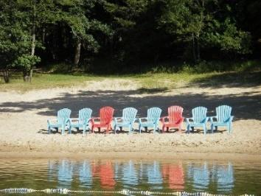**Waterfront / Beach Time** – 1:30-5:00 on Sunday, Monday and Tuesday – Swimming, sunning, canoes, kayaks, and lots of conversation. Please do not go to the waterfront if Camp Lakotah staff are not present.

**Worship Music** - Dee Kaker All are invited to participate in the worship services through song and instruments. All are welcome!

**\*Activities with an asterisk have limited space. Sign up at camp check in. Massages are scheduled before arrival at camp and at camp if there are cancellations.**